**User Manual For:**

**“Sign Language Based Communication System for (hearing and speaking impaired OR) deaf and dumb people”**

**Name:M Faizan Shafiq**

**Reg#:UW-14-CPS-BS-136**

**Name:Blilal Abbas**

**Reg#:UW-14-CPS-BS-142**

**Sec: “B”**



### **DEPARTMENT OF COMPUTER SCIENCES**

# **UNIVERSITY OF WAH,**

##### **WAH CANTT – PAKISTAN**

##### SESSION

##### 2014-2018

**Users of System:**

1. Normal peoples

2. Impaired peoples (e.g. Hearing and speaking wise).

**Main page of website:**

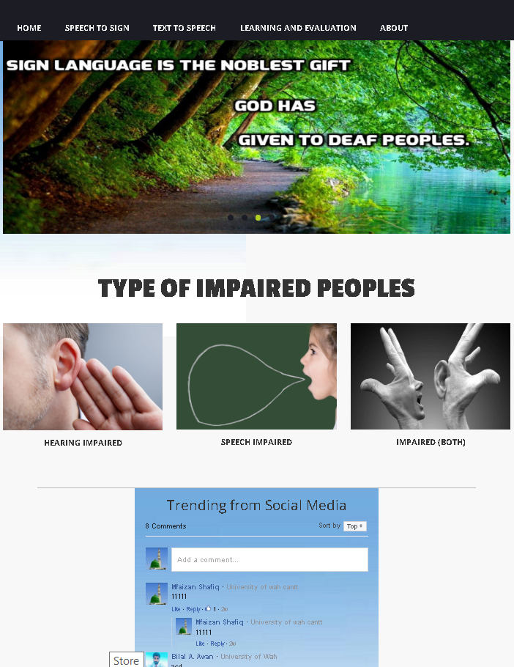

Section No.4 This image box has the detail of that type of peoples who can’t listen as well as speak

Section No.2 This image box has the detail of that type of peoples who can’t listen

Section No.3 This image box has the detail of that type of peoples who can’t Speak

Section No.1 having links of different pages

Section No. 5

Social Media section

**Sec.1.1 Home:**

**After the section 1 having all websites links we have following 3 sections which are.**

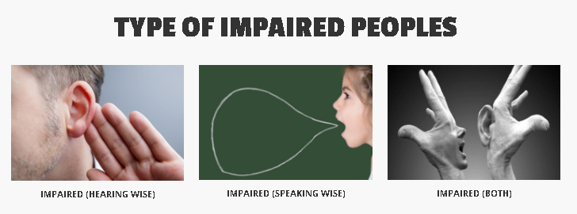

Section 4

Section 3

Section 2

**Section 2 (HEARING IMPAIRED)**

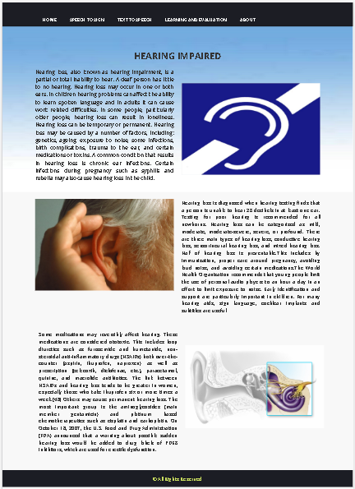After clicking of user on this page a web page will appear having information about the peoples having week sensation of listening or impaired to listening completely.

Section 2.1 is the web page which will appear which is given.

**Section 3 (IMPAIRED SPEECH IMPAIRED).**

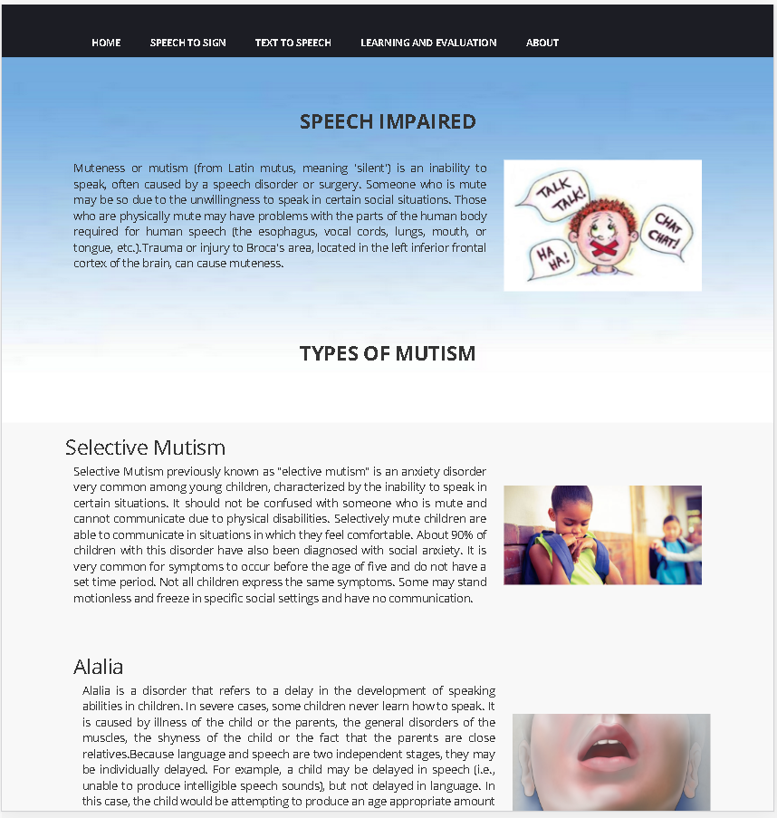After clicking of user on this page a web page will appear having information about the peoples having week sensation of speaking or impaired to speak completely.

Section 2.2 is the web page which will appear is given.

**Section 4 (IMPAIRED BOTH).**

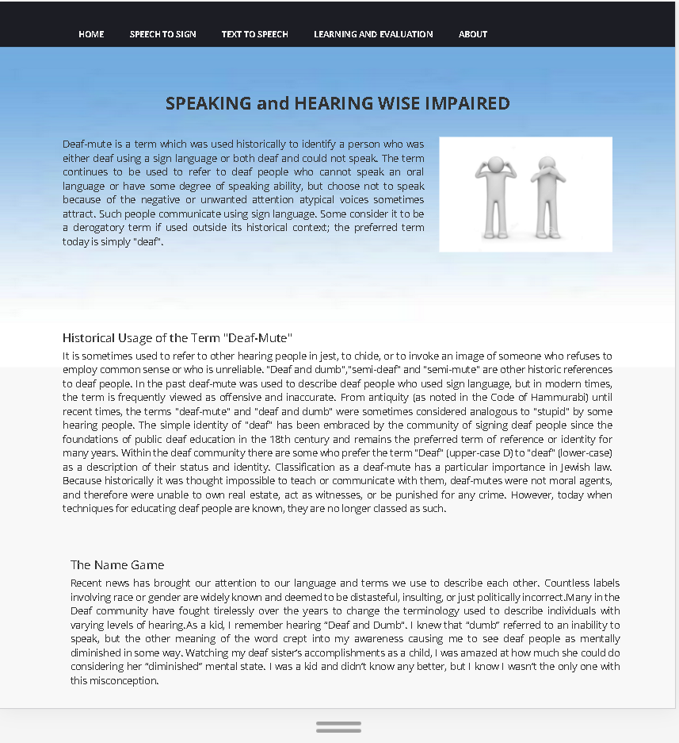After clicking of user on this page a web page will appear having information about the peoples having week sensation of speaking and listening.

Section 2.2 is the web page which will appear is given.

**Section 1.2(Speech to Text):**

**After clicking this link tab the following web page will appear.**

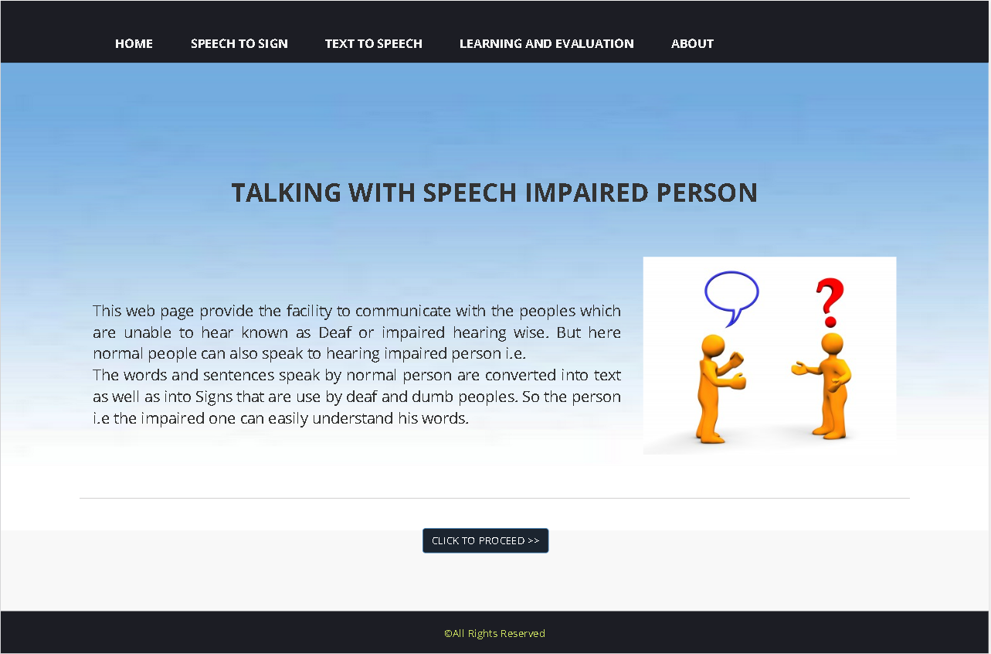

This button will provide Speech to sign web app.

**Section 1.2.1(WEB APP FOR COMMUNICATION):**

This page contain the following web app which will be use by normal user to communicate with peoples which are impaired hearing wise.

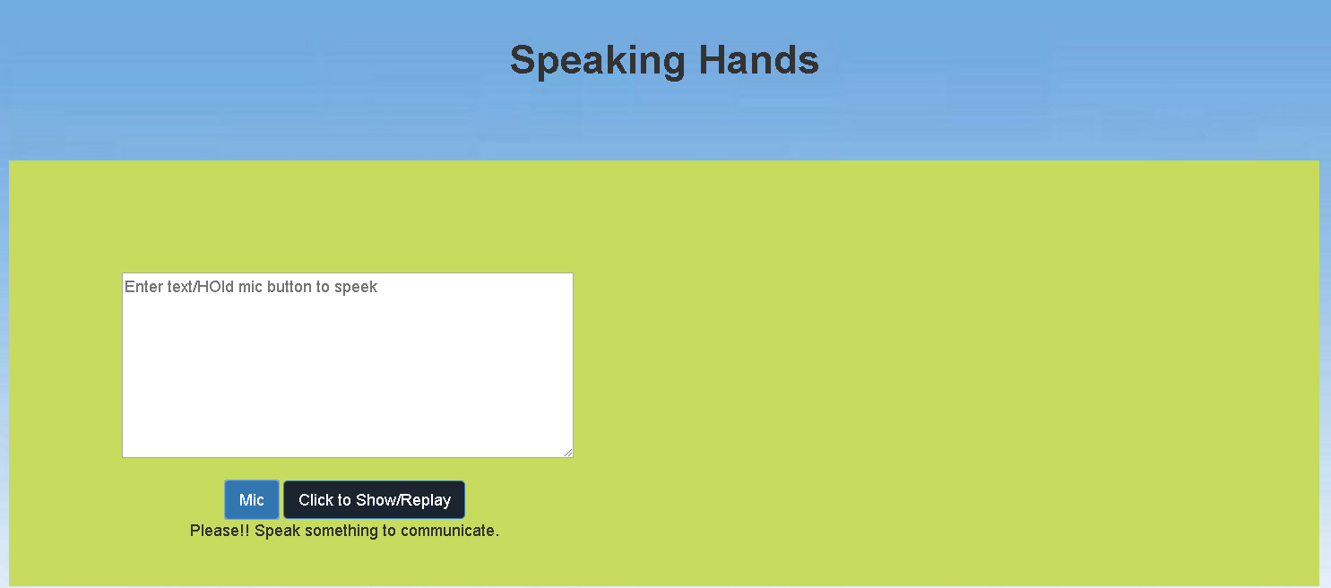

This window will show relevant sign so hearing impaired person can understand that what the normal person want to say.

This window shows extracted text from the user’s voice.

By clicking this button the speech recognition will stop.

By clicking this the app will start listening to the user (normal person)

**Section 1.3 (TEXT TO SPEECH):**

This page contain the web page having a web app for the speaking wise impaired persons who are unable to speak.so they type their respective words and app will speak out as it is.

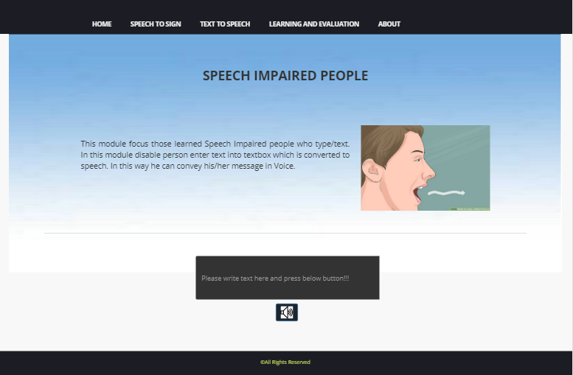

After entering text he/she have to click the button and app will convert the text into voice.

User (speaking) wise impaired person will type here.

**Section 1.4 (LEARNING AND EVALUATION):**

Before learning and evaluation link tab one have to go through the REGISTRATION and LOG-IN procedures so after clicking this tab following web page will appear.

**Section 1.4.1 (Registration):**

After clicking register link user following page will appear.

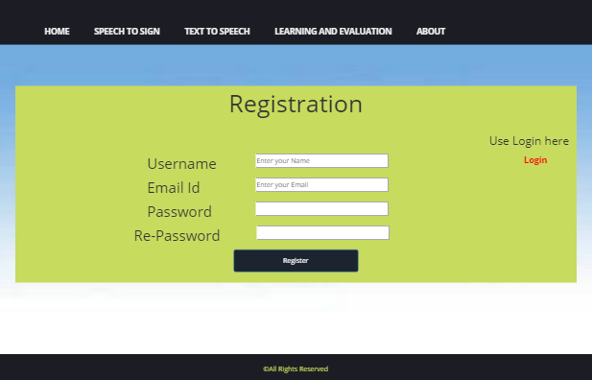

After filling the valid information click to register.

For confirmation retype password

Enter your respective password which will be use in future for login.

Enter valid email ID

Enter user name which will be used for log in

After click on Register button following confirmation popup will generate to conform registration.

After click on Register button following confirmation popup will generate to conform registration.

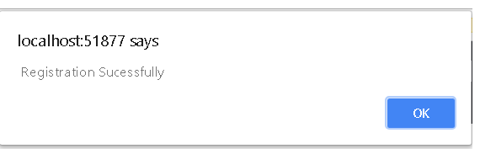

After this click on ok and then on login link.

**Section 1.4.2 (LOG-IN):**

Registered user will login here to access allowed options.

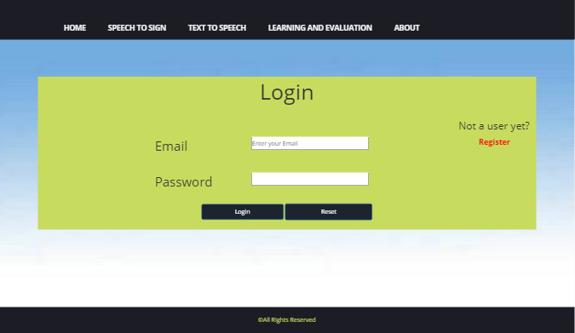

Click this button to reset the above text fields

Click this button to login after filling the above text fields.

Enter registered user name in this field

Enter your password

Click on this link for registration if you are not a registered user

**Section 1.4.2(after log in):**

**Following web page will appear.**

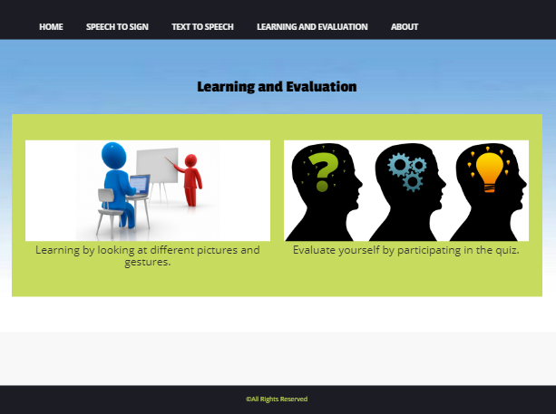

Section 1.4.2.1

For learning sign language

Section 1.4.2.2

For participating in Quiz

**Section 1.4.2(i) (Learning):**

This section is for the users who want to learn something e.g. by typing English words and learn the relevant meaning of that specific word.

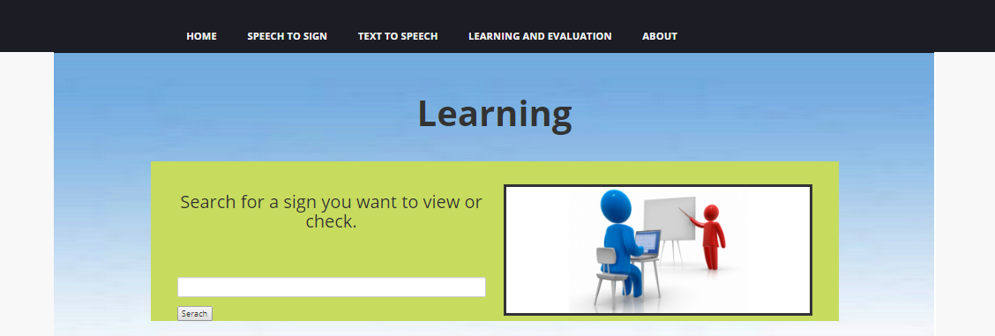

This field is use to enter text i.e. English words which you want to know

This window show the entered sign

Click this button to learn the sign

**Section 1.4.2(ii) (Contribution):**

This section is use for those user who want to contribute to our database by uploading sign relevant videos or pictures.

Here the user will see the uploaded image

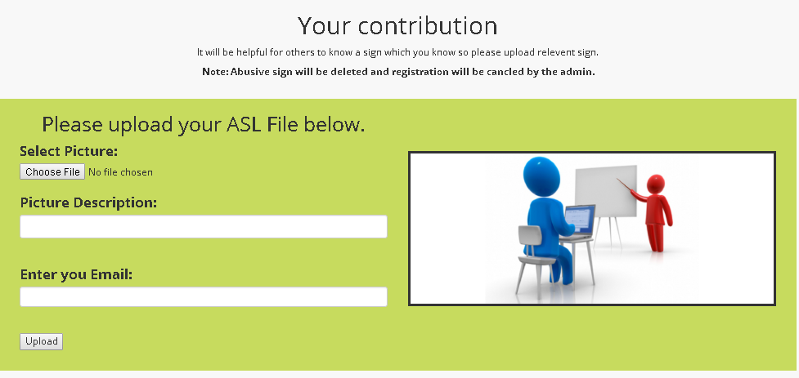

Click to select the file from your device

In this field user enter the description of his uploaded file.

Only registered user can upload file so he/she have to enter email-id.

**Section 1.4.2(iii) (manual learning slider):**

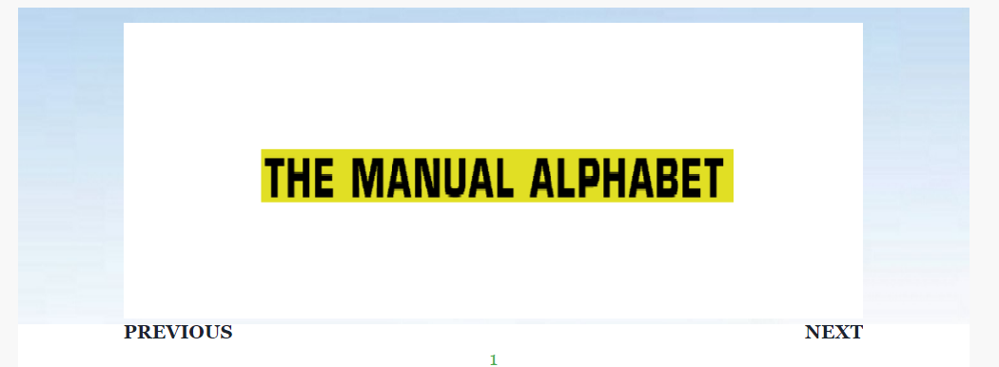

Click for next sign

Click for previous sign

**Section 1.4.2.2 (manual learning slider):**

**Section 1.4.2.1(i) (Start Quiz):**

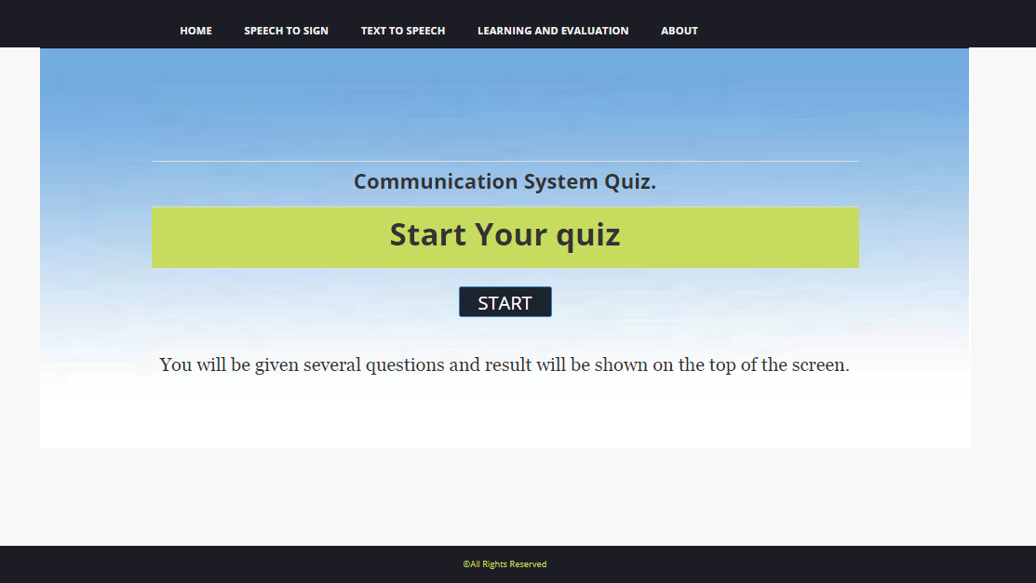

Click for start Quiz

**Section 1.4.2.2 (Quiz):**

Options

Quiz Timing

